Cavers
Please report Bat Observations to the Montana Natural Heritage Program*
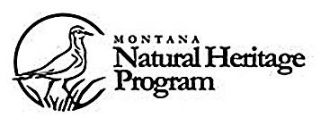
Bryce Maxell
bmaxell@mt.gov
(406) 444-3655
1515 East 6th Avenue, Helena, MT 59620
Access this form online at http://mtnhp.org/observations.asp
Or enter data directly online at http://mtnhp.org/observationform/

Information Requested
Mine or Cave Name:

Map Coordinates or Township, Range, Section:

Date Visited:

Observer: Observer Contact Info:

Bats Observed: Yes / No Bat Sign (guano/droppings) Observed: Yes / No

Numbers of Bats Observed by Species (describe size, color, or ear length if possible):

Photos taken of bats/droppings: Yes / No If yes, please forward high resolution examples.
Please take photos! They are very valuable for species identification and have been used for detection of White-Nose Syndrome.

Comments on cave/mine in general or microclimate occupied by bats (temperature, relative humidity). Was there condensation on bats or on adjacent walls/ceiling?

Comments on animals/droppings observed:

*Note that, as per the Federal Cave Resource Protection Act and Montana Cave Conservation Act, this information is not made available to the general public and is only made readily available to federal and state biologists to assist with the conservation and management of these species.

